Manan Shah

22bce0618  GitHub repo: https://github.com/manan04shah/bcse203e-web-programming

Web Programming Activity 4

Q)

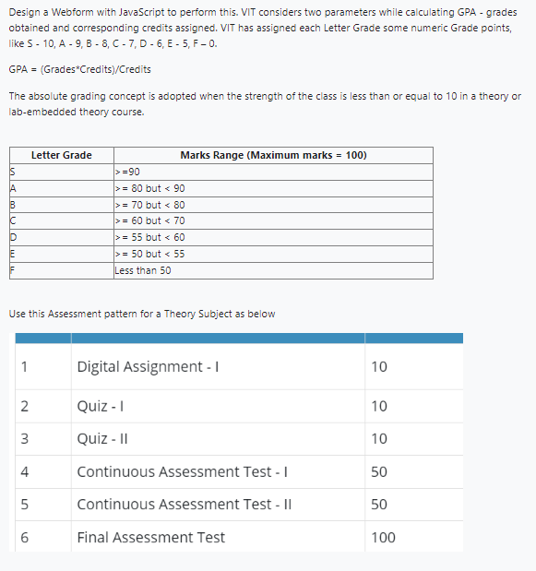

HTML:

<!DOCTYPE html>

<html lang="en">

<head>

    <meta charset="UTF-8">

    <meta name="viewport" content="width=device-width, initial-scale=1.0">

    <title>Absolute Graded CGPA Calculator</title>

    <link rel="stylesheet" href="../styles/style.css">

    <script src="../scripts/script.js"></script>

</head>

<body>

    <div class="formDiv">

        <form action="" method="post">

            <div class="courseOne">

                <div class="details">

                    <label for="courseOne">Course 1 Name: </label>

                    <input type="text" name="courseOne" id="courseOne">

                    <label for="courseOne">Course 1 Credits: </label>

                    <input type="number" name="courseOneCredits" id="courseOneCredits">

                </div>

                <br>

                <div class="marks">

                    <div class="submarks">

                    <label for="courseOne">DA 1 Marks: </label>

                    <input type="number" name="courseOneDA1" id="courseOneDA1" step="0.1">

                    </div>

                    <div class="submarks">

                    <label for="courseOne">Quiz 1 Marks: </label>

                    <input type="number" name="courseOneQuiz1" id="courseOneQuiz1" step="0.1">

                    </div>

                    <div class="submarks">

                    <label for="courseOne">Quiz 2 Marks: </label>

                    <input type="number" name="courseOneQuiz2" id="courseOneQuiz2" step="0.1">

                    </div>

                    <div class="submarks">

                    <label for="courseOne">CAT 1 Marks: </label>

                    <input type="number" name="courseOneCAT1" id="courseOneCAT1" step="0.1">

                    </div>

                    <div class="submarks">

                    <label for="courseOne">CAT 2 Marks: </label>

                    <input type="number" name="courseOneCAT2" id="courseOneCAT2" step="0.1">

                    </div>

                    <div class="submarks">

                    <label for="courseOne">FAT Marks: </label>

                    <input type="number" name="courseOneFAT" id="courseOneFAT" step="0.1">

                    </div>

                </div>

            </div>

            <br>

            <div class="submitButtonDiv">

                <input value="Calculate" class="submitButton" onclick="calculateGPA()">

                <div class="displayGrade">

                </div>

            </div>

        </form>

    </div>

</body>

</html>

CSS:

\* {

    margin: 0;

    padding: 0;

}

body {

    font-family: Arial, sans-serif;

    background-color: #f4f4f4;

}

.formDiv {

    display: flex;

    justify-content: center;

    align-items: center;

    height: 100vh;

}

form {

    border: 1vh solid black;

    padding: 2vh;

    width: 65vw;

}

label {

    margin: 1vh 1vh;

    display: inline-block;

    width: 10vw;

}

.submitButton {

    margin: 2vh 1vh;

    display: inline-block;

    width: 10vw;

    padding: 1vh;

    background-color: #4CAF50;

    color: white;

    border: none;

    cursor: pointer;

}

.submitButtonDiv,

.displayDiv {

    display: flex;

    justify-content: center;

    align-items: center;

}

JavaScript:

function calculateGPA() {

    var subjName = document.getElementById("courseOne");

    var subjCreds = document.getElementById("courseOneCredits");

    var da1marks = document.getElementById("courseOneDA1");

    var quiz1marks = document.getElementById("courseOneQuiz1");

    var quiz2marks = document.getElementById("courseOneQuiz2");

    var cat1marks = document.getElementById("courseOneCAT1");

    var cat2marks = document.getElementById("courseOneCAT2");

    var fatmarks = document.getElementById("courseOneFAT");

*//Convert all marks to a float*

    var credits = parseInt(subjCreds.value);

    var da1 = parseFloat(da1marks.value);

    var quiz1 = parseFloat(quiz1marks.value);

    var quiz2 = parseFloat(quiz2marks.value);

    var cat1 = parseFloat(cat1marks.value);

    var cat2 = parseFloat(cat2marks.value);

    var fat = parseFloat(fatmarks.value);

    var weightageFAT = 0.4 \* fat;

    var internals = da1 + quiz1 + quiz2 + (0.3\*cat1) + (0.3\*cat2);

    var overallMarks = weightageFAT + internals;

    var grade = "B";

    var gpa = 0;

*if*(overallMarks >= 90) {

        grade = "S";

        gpa = 10;

    }

*else* *if*(overallMarks >= 80) {

        grade = "A";

        gpa = 9;

    }

*else* *if*(overallMarks >= 70) {

        grade = "B";

        gpa = 8;

    }

*else* *if*(overallMarks >= 60) {

        grade = "C";

        gpa = 7;

    }

*else* *if*(overallMarks >= 55) {

        grade = "D";

        gpa = 6;

    }

*else* *if*(overallMarks >= 50) {

        grade = "E";

        gpa = 5;

    }

*else* {

        grade = "F";

        gpa = 0;

    }

    console.log("Internal Marks: ", internals, " | Overall Marks: ", overallMarks, " | Grade: ", grade, " | GPA: ", gpa);

    var displayDiv = document.getElementsByClassName("displayGrade")

    displayDiv[0].innerHTML = "Grade: " + grade + " | GPA: " + gpa;

}

OUTPUT:

